Project Planning Phase
Project Planning Template (Product Backlog, Sprint Planning, Stories, Story points)
Date | 26 September 2026
Team ID | SWTID-2026-9430
Project Name | AI BlogNest API
Maximum Marks | 5 Marks

Product Backlog, Sprint Schedule, and Estimation – AI BlogNest
Sprint |  | User Story Number | User Story / Task | Story Points | Priority | Team Member
  Functional Requirement (Epic)
Sprint-1 | User Registration | USN-1 | As a user, I can register for AI BlogNest using my name, email, password, and confirm password. | 2 | High | Team Member 1
Sprint-1 | User Registration | USN-2 | As a user, I receive a confirmation email after successfully registering in AI BlogNest. | 1 | High | Team Member 2
Sprint-1 | User Login | USN-3 | As a user, I can log in to AI BlogNest using my registered email and password. | 2 | High | Team Member 1
Sprint-1 | Social Login | USN-4 | As a user, I can register or log in to AI BlogNest through Google/Facebook authentication. | 2 | Medium | Team Member 2
Sprint-1 | Dashboard | USN-5 | As a user, I can access my AI BlogNest dashboard after successful login. | 2 | High | Team Member 3
Sprint-2 | AI Blog Generation | USN-6 | As a user, I can enter a topic or keyword and generate a blog using AI. | 5 | High | Team Member 1
Sprint-2 | AI Blog Generation | USN-7 | As a user, I can select the desired blog tone, style, and length before generating content. | 3 | High | Team Member 2
Sprint-2 | Blog Editing | USN-8 | As a user, I can edit and customize the AI-generated blog content before publishing. | 3 | High | Team Member 3
Sprint-2 | Blog Management | USN-9 | As a user, I can save generated blogs as drafts and view them later. | 3 | Medium | Team Member 1
Sprint-3 | Blog Publishing | USN-10 | As a user, I can publish my completed blog on the AI BlogNest platform. | 3 | High | Team Member 2
Sprint-3 | Blog Search | USN-11 | As a user, I can search and find blogs using keywords or categories. | 3 | Medium | Team Member 3
Sprint-3 | Blog Sharing | USN-12 | As a user, I can share published blogs with others through social media or a share link. | 2 | Medium | Team Member 1
Sprint-3 | User Profile | USN-13 | As a user, I can view and update my AI BlogNest profile information. | 2 | Low | Team Member 2
Sprint-4 |  | USN-14 |  | 3 | High | Team Member 3
  Admin Management
  As an admin, I can manage users and monitor published blog content.
Sprint-4 | Analytics | USN-15 | As a user, I can view basic statistics such as blog views, likes, and engagement. | 3 | Medium | Team Member 1

Project Tracker – AI BlogNest
Sprint | Total Story Points | Duration |  | Sprint End Date (Planned) | Story Points Completed (as on Planned End Date) | Sprint Release Date (Actual)
  Sprint Start Date
Sprint-1 | 9 | 6 Days | 01 Oct 2026 | 06 Oct 2026 | 9 | 06 Oct 2026
Sprint-2 | 14 | 6 Days | 07 Oct 2026 | 12 Oct 2026 | 14 | 12 Oct 2026
Sprint-3 | 10 | 6 Days | 13 Oct 2026 | 18 Oct 2026 | 10 | 18 Oct 2026
Sprint-4 | 6 | 6 Days | 19 Oct 2026 |  | 6 | 24 Oct 2026
  24 Oct 2026

Velocity – AI BlogNest
For AI BlogNest, total planned story points are 39 across 4 sprints.
Average Velocity (AV):
$$AV=\frac{\text{Total Story Points}}{\text{Number of Sprints}} \\ AV=\frac{39}{4}=9.75$$
Average Velocity = 9.75 story points per sprint

Sprint-wise Velocity
Sprint | Story Points Completed | Velocity
Sprint-1 | 9 | 9
Sprint-2 | 14 | 14
Sprint-3 | 10 | 10
Sprint-4 | 6 | 6
Average | 39 | 9.75

AI BlogNest Sprint Velocity
Story points completed across the four planned sprints.

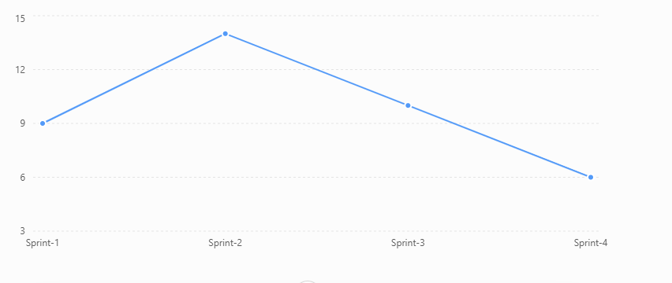

Project Name: AI BlogNest
Total Story Points: 39
Average Velocity: 9.75 story points/sprint

